NPS Wilderness Unit Workshops
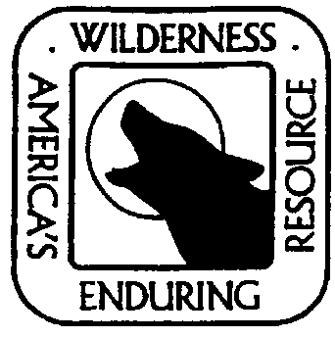
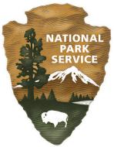

Interest/Request Form

Park Name: Click here to enter text. Park Superintendent: Click here to enter text.

Park Contact: Name/Position - Click here to enter text.
Phone - Click here to enter text.
Email - Click here to enter text.

Possible dates for training: Click here to enter text.

Why does your park need the training and is it a priority for park management?
Click here to enter text.

Specific training needs:
Does Day 1: Wilderness Overview generally meet your needs? What would you change? Click here to enter text.

What are specific wilderness stewardship issues or concerns at your park?
Click here to enter text.

What would be most important to include on the second day of the training?
Click here to enter text.

Would neighboring areas or agencies be interested in attending? Who?
Click here to enter text.

The park is committed to supporting widespread attendance by all employees, able to provide logistical support and can cover funding costs of the training.
Please explain: Click here to enter text.

- Call to discuss these questions further or send form to:
Tim Devine, NPS Representative
Arthur Carhart National Wilderness Training Center
Phone: 406-243-4612
Email: tim_devine@nps.gov

