Wilderness Air Quality Value (WAQV) Class 2 Monitoring Plan

Great Bear Wilderness, Flathead National Forest

Prepared by Mark Story, Dale Luhman, and Thomas Dzomba

April 3, 2007

This Wilderness Air Quality Value (WAQV) Class 2 Plan was prepared to:

1. Summarize the wilderness characteristics of the Great Bear Wilderness area (GBW),
2. Explain the legal framework for air quality protection,
3. Identify wilderness air quality values, and
4. Provide a monitoring plan for Wilderness Air Quality Values (WAQV’s).

The Great Bear Wilderness is Class 2 for the Clean Air Act Prevention of Significant Deterioration (PSD) regulations. Air quality protection authority (beyond ambient air quality standards and PSD increments) for this wilderness area therefore relies primarily upon the Wilderness Act, although the Class I Airsheds of Glacier National Park, Bob Marshall, Scapegoat and Mission Mountain Wilderness areas surround the Great Bear and also provide defacto air quality protection requirements. This plan is designed to specify appropriate monitoring to protect the Class 2 WAQV’s and to meet the Wilderness Stewardship Challenge to achieve the objectives of the Air Element #3 [http://www.wilderness.net/index.cfm?fuse=toolboxes&sec=air](http://www.wilderness.net/index.cfm?fuse=toolboxes&sec=air%20%20%20)

1) Location

The Great Bear Wilderness (GBW) is located in northwestern Montana on the western side of the Continental Divide on the Hungry Horse and Spotted Bear Ranger Districts of the Flathead National Forest, south of Glacier National Park (see Map 1). The Great Bear Wilderness is a 286,700 acre contiguous unit. The GBW along with the 1,009,356 acre Bob Marshall Wilderness, and 239,296 acre Scapegoat Wilderness, form the 1,535,352 acre Bob Marshall Wilderness Complex, the second largest wilderness area complex in the lower 48 states.

The GBW is bounded on the north by State Highway 2, on the east by the north end by the Skyland area and the Bob Marshall Wilderness. On the south the boundary is located one to two miles north of the Spotted Bear River Road 568. On the west edge the boundary is located one to three miles east of the East Side Reservoir Road 38 which runs the length of Hungry Horse Reservoir.

Recreational Impacts in the Bob Marshall Wilderness Complex are guided by the April 1987 Recreation Management Direction (USFS, 1987) in the Flathead, Helena, Lewis and Clark, and Lolo National Forest Plans. The 1986 Flathead and 1986 Lolo National Forest Plans are currently being revised, with draft plans released April 2006, and final forest plans expected in 2007. The Lewis and Clark and Helena National Forest Plans are expected to be revised in the next few years.

2) Wilderness Characteristics

Reviewing Public Law 95-546 and the associated Committee Report, gives some background on the creation of the Great Bear Wilderness area. In 1972 Congressional hearings and designation action began on the Great Bear Wilderness. The Great Bear Wilderness was designated by Congress on October 28, 1978. Inclusion of the Great Bear Wilderness in the National Wilderness Preservation System was a long time effort of the late U.S. Senator Lee Metcalf (D-Montana), who introduced the original bill and was its primary advocate. Metcalf died January 12, 1978, less than ten months before his goal was realized.

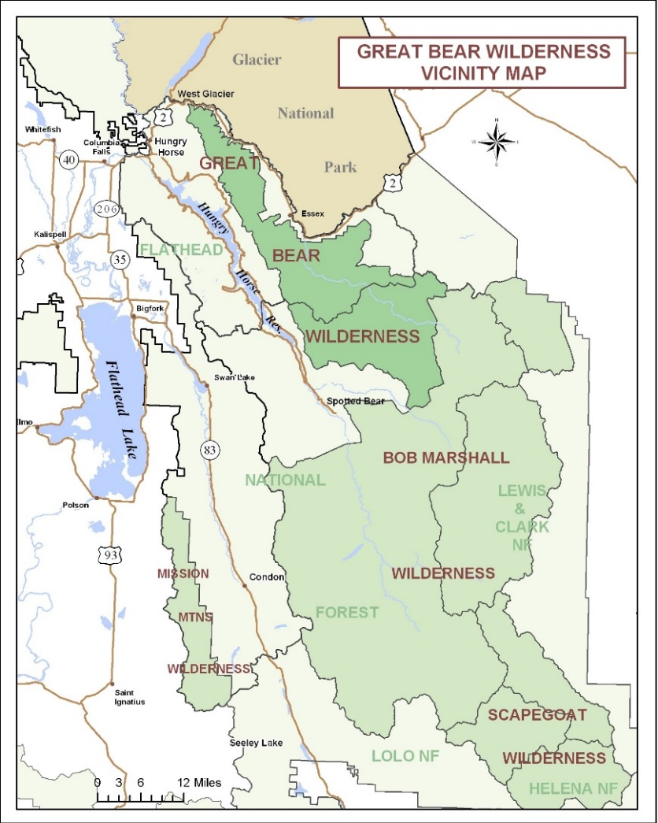

Map 1. Bob Marshall Wilderness Complex with the Great Bear Wilderness on the North side between the Bob Marshall Wilderness and Glacier National Park.

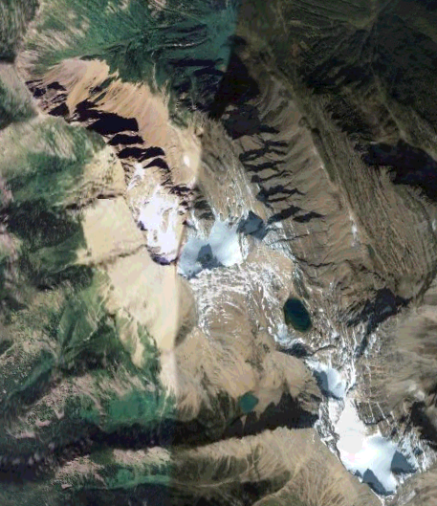

Photo 1. Portion of the crest of the Great Bear Wilderness including Great Northern Mountain, between the South Fork Flathead River and Hungry Horse (on left) Reservoir (on left) and the Middle Fork of the Flathead River watershed (on right). Stanton Glacier north and Grant Glacier south (Google Earth – Digital Globe).

Previous air quality plans for the area included the Bob Marshall Wilderness AQRV plan (Acheson, 1990) and the Scapegoat Wilderness AQRV plan (Story, 1996)

The GBW forms a critical ecological link between Glacier National Park and the Bob Marshall Wilderness. It completes the habitat protection for the most significant grizzly bear range in the lower 48 states. Besides grizzly bear, the wilderness contains important wildlife species such as the gray wolf, elk, lynx, wolverine, deer, elk, moose, black bear, and mountain goat. Habitat includes rugged ridge tops, gently sloping alpine meadows, and thickly forested river bottoms. All of the major wildlife species that existed when Lewis and Clark visited the area 200 years ago exist today. It has one of the outstanding native fisheries for westslope cutthroat trout and Dolly Varden (bull trout) in the United States.

The western edge of the wilderness runs about 36 miles long the Flathead Range, which includes a “panhandle” of land between the Middle Fork and South Fork Flathead River drainages (see Photo 1). The panhandle contains 8,705 foot high Great Northern Mountain, the highest point in the wilderness (see Photo 2). The GBW widest point is about 34 miles.

.

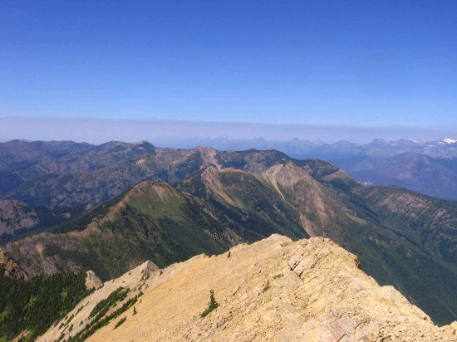

Photo 2. From Great Northern Mountain, 8,705’, looking north

The wilderness is characterized by high, rugged topography and a primitive environment. The Middle Fork of the Flathead River drains most of the wilderness. The area is dominated by dense lodgepole pine forest, with alpine larch and whitebark pine at the upper elevations.

The wild section of the Middle Fork Flathead Wild and Scenic River is part of the National Wild and Scenic Rivers System. The Wild and Scenic River segment begins in the upper end of the Middle Fork Flathead River in the Bob Marshall Wilderness at Gooseberry Park. It flows 10.6 miles until it reaches the Great Bear Wilderness. It then flows for another 35 miles until it leaves the wilderness near Bear Creek.

The Upper Middle Fork corridor is characterized by views of forests, river canyon, and mountainous terrain (see Photo 3). The river is free-flowing and has exceptional water quality. Most of the corridor is primitive or natural appearing, except for the Schafer Meadows area with its work center and airstrip.

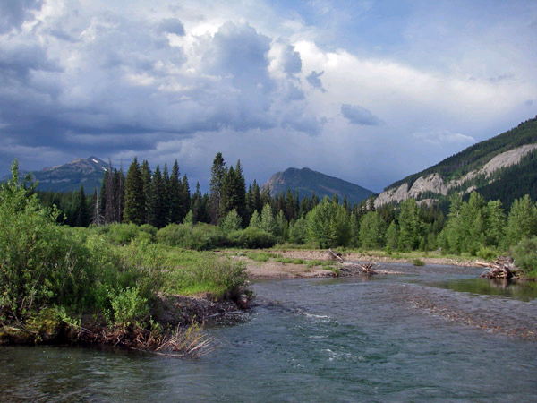

Photo 3. Middle Fork Flathead River – upper section

The Schafer Meadows Work Center is located just outside the river corridor and consists of seven buildings, corral, airstrip, and developed campground. The airstrip is used extensively by river floaters. Spruce Park and Granite administrative cabins are located in the river corridor. Each cabin has a corral, barn, and outhouse associated with it. There is no privately owned land within the GBW. The GBW is managed by two Ranger Districts with trail miles, and Wild river miles specified in Table 1 below.

Table 1. Great Bear Wilderness Trail and Wild River miles.

|  |  |  |  |
| --- | --- | --- | --- |
| Great Bear Wilderness | | | |
|  | Acres | Trail miles | Wild River miles |
| Spotted Bear RD | 136,756 | 131 | 17 |
| Hungry Horse RD | 149,944 | 180 | 18 |
| Flathead NF total | 286,700 | 311 | 35 |

Backcountry recreation uses include backpacking, stock use, hunting, floating, and fishing. More than 300 miles of hiking and stock trails provide access to the Great Bear Wilderness. Whitewater rafting on the upper Middle Fork has increased substantially. Hiking and stock use is focused on the short hikes to lakes and peaks in the panhandle, and longer access trails in the eastern end of the wilderness in the summer. Fall brings some early season hunting in the wilderness, mostly with pack stock. Lower elevation areas include deep canyon country, with extensive avalanche chutes.

Wilderness outfitters provide summer roving horse pack trips and fall hunting out of outfitter base camps. A few outfitters provide float trips down the Middle Fork Flathead River. Aircraft use of the landing strip at Schafer Meadows, allowed by legislation, is regulated with limits on the number of landings. Schafer Meadows has the only open airstrip in the Bob Marshall Wilderness Complex. The main recreation use is floating the Middle Fork Flathead Wild and Scenic River during May and June with its class 2, 3, 4 and 5 rapids. Some pilots fly into Schafer Meadows airstrip for day use or use it as a trailhead to access the upper end of the wilderness.

The general density of the river corridor use is low to moderate. The Schafer Meadows river launch point is often congested, especially on weekends. During the relatively short float season, daily encounters are estimated to be low (2 to 4) among float parties, low to moderate (2 to 10) among land-based parties, and low between float and shore parties.

The Upper Middle Fork Management Unit is managed to provide challenging whitewater opportunities in an essentially unmodified wilderness environment where encounters with and evidence of other users is low. Primary access for floaters is by airplane or pack stock (see Photo 4).

The river above Three Forks is generally gentle and meandering with no major rapids. The river above Schafer Meadows is small and is rarely floated. Below the Three Forks area the river is in a confined canyon. The river gradient averages 35 feet of drop per mile with numerous major rapids, rated up to Class 5 on the International Whitewater Scale. The river level is generally suitable for floating between May 25 and July 15.

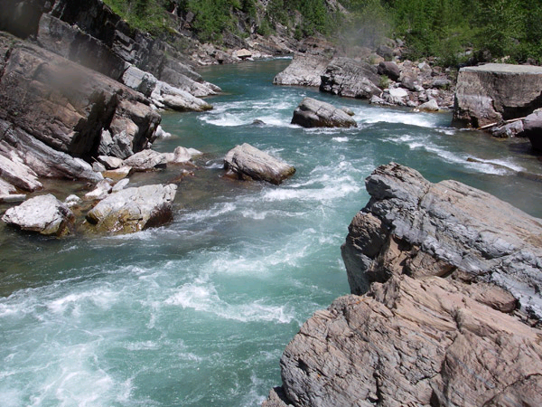

Photo 4. Spruce Park on the Middle Fork Flathead River- lower section

The Great Bear Wilderness has 85 lakes on National Forest lands including 71 of the 88 lakes in the entire Middle Fork Flathead River drainage, and 14 of the 356 lakes in the entire South Fork Flathead River drainage. In the GBW approximately 17 lakes in the Middle Fork and none of the South Fork lakes contain fish. All 85 lakes were originally fishless and have been historically planted with westslope cutthroat trout. The lakes are located at elevations ranging from 3,850 feet at Stanton Lake, to 7,690 feet for an unnamed lake. The highest named lake is 6,960 foot elevation Pot Lake. The largest lakes include 147 acre Flotilla, 79 acre Stanton, 68 acre Marion, and 60 acre Moose Lake. The majority of the 85 lakes are less than 2 acres in size.

The river contains three species of fish, bull trout, westslope cutthroat, and mountain whitefish. The Middle Fork provides important habitat for bull trout and westslope cutthroat trout.

3) Policy and Direction

The Wilderness Act of 1964 contains language directing the management of wilderness to “…secure for the American people…and future generations the benefits of an enduring resource of wilderness …unimpaired for future use and enjoyment” (Wilderness Act, PL 88-577, Sec. 2a) It further states that Congress intended to manage these wildernesses so that “…the earth and it’s community of life are untrammeled by man…” and a wilderness must”…retain it’s primeval character and influence…” and it”…appears to have been affected primarily by the forces of nature, with the imprint of man’s work substantially unnoticeable” (Sec 2b). The direction provided in this act made it clear that Congress intended that the natural conditions in wilderness be preserved and that it be influenced primarily by the forces of nature rather than by human activity. The basic framework for controlling air pollutants in the United States is mandated by the Clean Air Act (CAA) of 1963, and amended in 1970, 1977, and 1990. The CAA was designed to “protect and enhance” air quality. Section 160 of the CAA requires measures “to preserve, protect, and enhance the air quality in national parks, national wilderness areas, national monuments, national seashores, and other areas of special national or regional natural, recreation, scenic, or historic value.” Stringent requirements are therefore established for areas designated as “Class I” areas. Class I areas include Forest Service and Fish and Wildlife Service wilderness areas over 5,000 acres that were in existence before August 1977 and National Parks in excess of 6,000 acres as of August 5, 1977. Designation as a Class I area allows only very small increments of new pollution above already existing air pollution levels. Class II areas include all other areas of the country that are not Class I. To date, there are no class III areas. The Great Bear Wilderness was designated Class II areas since it was established after 8/5/1977 (October 28, 1978).

The purpose of the CAA is to protect and enhance air quality while ensuring the protection of public health and welfare. The act established National Ambient Air Quality Standards (NAAQS), which must be met by state and federal agencies, and private industry. The EPA has established NAAQS for specific pollutants emitted in significant quantities that may be a danger to public health and welfare. These pollutants are called criteria pollutants and include carbon monoxide, nitrogen oxide, ozone, sulfur dioxide, lead, and particulate matter (PM10 and PM2.5). States are given primary responsibility for air quality management. Section 110 of the Clean Air Act requires States to develop State Implementation Plans (SIP) that identify how NAAQS compliance will be achieved. The NAAQS are designed to protect human health and public welfare. The CAA defines public welfare effects to include, but not be limited to, “effects on soils, water, crops, vegetation, man-made materials, animals, wildlife, weather, visibility and climate, damage to and deterioration of property, and hazards to transportation, as well as effects on economic values and on personal comfort and well-being” (CAA Title 1, Part A, S. 109 <http://www.epa.gov/air/criteria.html>). If a community or area does not meet or “attain” the standards, it becomes a non-attainment area and must demonstrate to the public and EPA how it will meet standards in the future. This demonstration is done through the SIP process.

Criteria pollutants such as sulfur dioxide and nitrogen dioxide are of concern because of their potential to cause adverse effects on plant life, water quality, aquatic species, and visibility. However, sources of these pollutants are generally associated with urbanization and industrialization rather than with natural resource management activities or wildfire. Wildfire and natural resource management activities such as timber harvest, road construction, site preparation, mining, and fire use can generate ozone, carbon monoxide, and particulate matter. While ozone is a by product of fire, potential ozone exposures are infrequent. The EPA is recommending a secondary ozone standard which will protect vegetation and animals <http://www.epa.gov/ttn/naaqs/standards/ozone/s_o3_cr_sp.html>. Carbon monoxide is rapidly diluted at short distances from a burning area, as fires are generally spatially and temporally dispersed, and pose little or no risk to public health.

The pollutant of most concern to public health and visibility in the Great Bear Wilderness is particulate matter. Even though particulate matter has no serious effects on ecosystems (fire and smoke are natural processes) it does affect human health and visibility. Because of its smaller size, PM2.5 poses greater respiratory health system risks than PM10.

The PM2.5 standard requires concentrations of PM2.5not to exceed a 24-hr average of 35 ug/m3 (micrograms per cubic meter). This standard was changed from the previous 65 ug/m3 by the EPA on 12/17/06 <http://www.epa.gov/particles/fs20061006.html>. Average annual arithmetic PM2.5 concentrations are not to exceed 15 ug/m3. Air quality State Implementation plan (SIP) for particulates is promulgated through the Montana Clean Air Act and implementing regulations. The regulations provide specific guidance on maintenance of air quality, including restrictions on open burning (ARM 16.8.1300). The act created the Montana Air Quality Bureau (now the DEQ) and the regulatory authority to implement and enforce the codified regulations.

4) Pollution Sources and Air Quality Conditions

No specific information is available concerning existing air quality in the GBW.

The population (and related air pollution potential) of Flathead County, located directly west of the Great Bear Wilderness, has increased at a much greater pace than Montana and the rest of the United States. This could have short and long term air quality affects from home construction, road construction, traffic, etc.

|  |  |  |  |
| --- | --- | --- | --- |
|  | 1970 | 2005 | Percent increase |
| Flathead County | 39,460 | 83,172 | + 110% |
| Montana | 694,409 | 935,670 | +34 |
| United States | 203,211,926 | 298,444,215 | +46 |

Climate

Most of the GBW is mountainous, ranging in elevation from 3,800 to 8,705 feet. Essex is located immediately north of the GBW at 3,800 feet. It averages 40 inches of annual

precipitation, with 199 inches of snowfall. Average annual precipitation includes 4 to 6 inches of precipitation fall each month from November to January, 2 to 3 inches/month from March to June, less than 2inches in July and August, and 3 inches in September and October. Snowfall averages 6 inches in October, 20 inches in November, and 40-60 inches a month from December through February, 20 inches in March, and 6 inches in April to total 199 inches. Precipitation and snowfall is estimated to be double these amounts on the higher mountain ridges of the GBW.

Average minimum and maximum temperatures range from 12 to 26 degrees in January, and from 44 to 82 in July in Essex. Winds tend to blow from west to east, however occasionally in the winter arctic cold fronts come down from Canada into eastern Montana and winds and cold blow east to west over Marias Pass and down the Middle Fork of the Flathead River.

Air Quality

The GBW air quality is currently considered to be good with limited upwind large stationary local emission sources and periodic robust wind dispersion. Existing sources of emissions in the wilderness area includes dust from trails during dry conditions and smoke emissions from wildfires, and prescribed burns. The GBW may have wildland fire use in the future. Adjacent area emissions include occasional construction equipment, vehicles, road dust, residential wood burning, wood fires, and smoke from logging emissions slash disposal, prescribed burns, wildfires, and wildland fire use. The GBW receives vehicle, residential, and construction emissions from the from the upper Flathead valley (Kalispell, Columbia Falls, Whitefish, Hungry Horse, and West Glacier). The GBW has very limited local sources. Down valley airflow in the GBW drainages (mainly the South and Middle Forks of the Flathead River) is frequently robust during nighttime and early morning hours. The entire GBW is considered to be in attainment by the Montana DEQ <http://www.deq.mt.gov/AirQuality/Planning/AirNonattainment.asp>

The major source of emissions in the upper Flathead valley includes vehicle exhaust, wood burning smoke, and road dust, and industrial emissions. The main permitted industrial sources in the Flathead valley include Columbia Falls Aluminum Company (currently only partially in operation) for sulfur dioxides (SOx) and particulates and 2 Plum Creek facilities (Kalispell and Columbia Falls) for nitrogen oxides (NOx) and PM10. The EPA Aerometric Information Retrieval System (AIRS) data base <http://www.epa.gov/air/data/netemis.html> lists 25 primary station sources of emissions within a 60 mile radius of the GBW (see Table 2). The AIRS database includes 1999 GBW emission levels in the GBW area which combine for about 794 tons/year of NOx, 2,362 tons/year of PM10, and 1,435 tons/year of SO2. Kalispell, Columbia Falls, and Whitefish are designated non-attainment areas by the Montana DEQ for PM10 <http://www.deq.mt.gov/AirQuality/Planning/AirNonattainment.asp> East of the Great Bear Wilderness several stationary sources in Glacier and Teton Counties (primarily in Cut Bank) produce primarily NOx emissions from natural gas processing and transportation facilities. The very strong dispersion and predominantly west to east wind direction transports most of these eastside emissions downwind of the GBW.

**Table 2. Great Bear Wilderness general area stationary emission sources.**

| **[Pollutant Emissions](javascript:toHelp('http://www.epa.gov/air/data/help/hnetemis.html" \l "Pollutant Emissions'))** | | | | | | |
| --- | --- | --- | --- | --- | --- | --- |
| [**CO**](javascript:toHelp('http://www.epa.gov/air/data/help/hnetemis.html#Pollutant Emissions')) | [**NH3**](javascript:toHelp('http://www.epa.gov/air/data/help/hnetemis.html#Pollutant Emissions')) | [**NOx**](javascript:toHelp('http://www.epa.gov/air/data/help/hnetemis.html#Pollutant Emissions')) | [**PM10**](javascript:toHelp('http://www.epa.gov/air/data/help/hnetemis.html#Pollutant Emissions')) | [**PM2.5**](javascript:toHelp('http://www.epa.gov/air/data/help/hnetemis.html#Pollutant Emissions')) | [**SO2**](javascript:toHelp('http://www.epa.gov/air/data/help/hnetemis.html#Pollutant Emissions')) | [**VOC**](javascript:toHelp('http://www.epa.gov/air/data/help/hnetemis.html#Pollutant Emissions')) | [**Facility Name**](javascript:toHelp('http://www.epa.gov/air/data/help/hnetemis.html#Facility Name')) | [**Location**](javascript:toHelp('http://www.epa.gov/air/data/help/hnetemis.html#Facility Mailing Address')) | [**County**](javascript:toHelp('http://www.epa.gov/air/data/help/hnetemis.html#County')) |
| 32,523 |  | 10.6 | 1,447 | 1,268 | 1,386 | 345 | Columbia Falls Aluminum | Columbia Falls | Flathead |
| 1,365 |  | 150 | 156 | 111 | 9.28 | 27.0 | Plum Creek Evergreen | Kalispell | Flathead |
| 1,080 | 0.01 | 480 | 445 | 323 | 15.5 | 191 | Plum Creek Manufacturing, L.P. | Columbia Falls | Flathead |
| 94.7 |  | 5.45 | 178 | 130 | 1.07 | 2.58 | American Timber Company | Olney | Flathead |
| 58.8 |  | 23.3 | 1.54 | 1.53 | 0.08 | 11.6 | MPC Cut Bank Mainline #1 Station | Cut Bank | Glacier |
| 24.0 |  | 4.08 | 64.4 | 50.5 | 0.90 | 23.1 | Stoltze Land And Lumber Company | Columbia Falls | Flathead |
| 10.0 |  | 21.4 | 0.06 | 0.06 |  | 20.7 | Little Rock Compressor Station | Cut Bank | Glacier |
| 6.91 |  | 16.1 |  |  |  | 0.83 | Montana Power Gas Company - Station 025 | Cut Bank | Glacier |
| 5.97 |  | 2.77 | 0.03 | 0.03 |  | 6.96 | Gypsy Highview-Red River Station | Cut Bank | Glacier |
| 4.96 |  | 24.7 |  |  |  | 16.7 | Montana Power Gas Company - Station 015 | Cut Bank | Glacier |
| 3.98 |  | 2.78 |  |  |  | 9.70 | Montana Power Gas Company - Station 002 | Cut Bank | Glacier |
| 3.61 |  | 4.06 |  |  |  | 5.50 | Montana Power Gas Company, Station 001 | Cut Bank | Glacier |
| 3.44 |  | 0.51 | 5.21 | 2.15 | 1.96 | 1.58 | Pack & Company | Kalispell | Flathead |
| 3.20 |  |  | 0.11 | 0.08 |  | 0.30 | Partners In Wood | West Glacier | Flathead |
| 3.07 |  | 25.0 |  |  |  | 16.5 | Montana Power Gas Company - Station 018 | Cut Bank | Glacier |
| 2.89 |  | 1.58 | 12.5 | 5.25 | 6.36 | 8.04 | A-1 Paving, Inc. | Kalispell | Flathead |
| 1.91 |  | 7.75 | 0.03 | 0.03 |  | 4.97 | Blackfeet Shallow Gas Systems | Cut Bank | Glacier |
| 1.74 |  | 6.95 | 7.20 | 2.93 | 14.7 | 3.99 | Flathead County Road Dept. – Asphalt | Kalispell | Flathead |
| 0.92 |  | 4.59 |  |  |  | 0.23 | Gypsy Highview Gathering Systems | Pendroy | Teton |
| 0.44 |  | 1.89 | 0.05 | 0.05 |  | 0.38 | Mpc - Cobb Storage Field, Station 017 | Cut Bank | Glacier |
| 0.16 |  | 0.80 | 14.5 | 10.6 |  | 0.04 | Stillwater Forest Products | Kalispell | Flathead |
|  |  | 0.01 | 0.03 | 0.03 | 0.05 | 0.01 | Johnson Mortuary | Kalispell | Flathead |
|  |  |  | 22.1 | 7.21 |  |  | Busch Agricultural - Fairfield Elevator | Fairfield | Teton |
|  |  |  |  |  |  | 207 | Cenex, Inc. Cut Bank/Big Sky Pipeline | Cut Bank | Glacier |
|  |  |  | 5.85 | 4.33 |  |  | Klingler Lumber | Kalispell | Flathead |
| 35,198 | 0.01 | 794 | 2,362 | 1,917 | 1,435 | 920 |  |  |  |

The nearest Class I area to the GBW is the Bob Marshall Wilderness which abuts the GBW on the south and east. Glacier National Park, also a Class 1 area, parallels the north border of the GBW for about 48 miles. The narrow Highway 2/Middle Fork of the Flathead River corridor separates the GBW from Glacier NP. In a few spots the corridor is only 0.5 miles wide. The GBW receives “de-facto” Class 1 air quality protection since it is between 2 Class 1 areas. Regional wildfire smoke has accumulated in much of Idaho and western Montana during periods of extensive wildfire activity in 1988, 1994, 2000, 2003, and 2006. The prime source of wildfire emissions is from central and northern Idaho, and western Montana. The episodic wildfire events are by far the most impactive factor affecting air quality and visibility in the GBW.

Lake Chemistry

The Great Bear Wilderness has about 85 lakes. Chemical records can indicate changes in a lake's composition, which in sensitive lakes is very diagnostic of atmospheric chemistry. Imbalance of lake chemistry can affect microorganisms, and invertebrates, ultimately affecting the health and productivity of fish. The lake chemistry of East Tranquil Basin Lake in the GBW (Table 3) was monitored on September 30, 1985 by the EPA (1985) Western Lake Survey (Landers, et.al, 1987) with the locations shown in map 3 from the USFS Air lake data website [at http://svinetfc2.fs.fed.us/waterchem/viewer.htm](at%20http://svinetfc2.fs.fed.us/waterchem/viewer.htm)

Table 3. Western Lake Survey data for East Tranquil Basin Lake.

|  |  |  |  |  |  |  |  |  |  |
| --- | --- | --- | --- | --- | --- | --- | --- | --- | --- |
|  |  |  |  | ANC | HCO3 | Ca | Mg | Na | K |
| Lake | Location | Lake ID | pH | ueq/l | ueq/l | ueq/l | ueq/l | ueq/l | ueq/l |
| East Tranquil Basin | 28N 15W S4 | 4C3-016 | 8.14 | 1387.2 | 1350.1 | 1097.9 | 278 | 15.1 | 3.3 |
|  |  |  |  |  |  |  |  |  |
|  |  | NH4 | SO4 | Cl | NO3 | F | Cond. |  |
| Location | Lake ID | ueq/l | ueq/l | ueq/l | ueq/l | ueq/l | uS/cm |  |
| 28N 15W S4 | 4C3-016 | 0.1 | 20.1 | 1.4 | 0.0 | 0.8 | 133.8 |  |

Map 2. Western Lake Survey (1985) sampling sites orange circles) around the GBW.

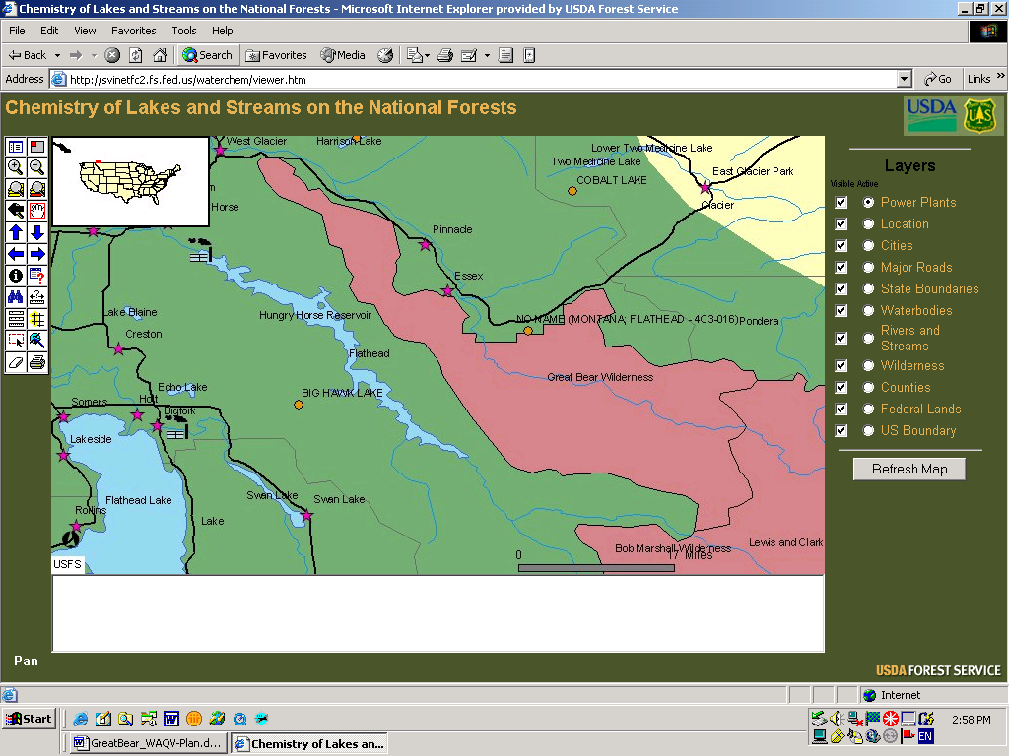

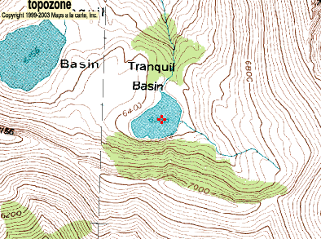

Map 3. East Tranquil Basin Lake which was sampled on 9/30/1985 in the EPA Western Lake survey and labeled as   
4C3-016 No Name lake

The Montana Department of Fish Wildlife and Parks (DFWP) sampled 12 lakes in the GBW by helicopter in July and August 1968 (data from NRIS at Montana State Library) Water chemistry data from the lake surveys include (DFWP, 1969):

Table 4. Montana DFWP 1968 Lake Data from the GBW.

|  |  |  |  |  |  |  |
| --- | --- | --- | --- | --- | --- | --- |
| Lake | Location | Elevation feet | Surface area acres | pH | HCO3 ueq/L | Cond. uhos/cm |
| Almeda | 29N 17W S24 | 5950 | 17.2 | 8.2 | 1540 | 124 |
| Bergsicker | 27N 16W S14 | 4790 | 5.0 | 8.0 | 1780 | 162 |
| Castle | 27N 14W S6 | 6100 | 17.0 | 8.0 | 1260 | 109 |
| Dickey | 29N 17W S13 | 5810 | 32.0 | 8.0 | 1000 | 84 |
| East Tranquil | 28N 15W S4 | 6100 | 12.2 | 7.8 | 1240 | 103 |
| Elk | 28N 15W S15 | 7100 | 22.4 | 8.3 | 1500 | 135 |
| Flotilla | 28N 14W S28 | 5150 | 146.0 | 7.7 | 680 | 50 |
| Marion | 29N 16W S17 | 5700 | 12.1 | 8.2 | 1700 | 149 |
| Stanton | 30N 17W S2 | 3630 | 77.0 | 8.1 | 1540 | 141 |
| Tunnel | 30N 17W S35 | 6400 | 13.7 | 7.9 | 960 | 81 |
| Upper Sheep | 28N 15W S4 | 6040 | 4.1 | 7.9 | 1460 | 124 |
| West Tranquil | 28N 15W S4 | 6000 | 51.6 | 8.2 | 1920 | 178 |

The 85 GBW lakes are located in the Precambrian Missoula Group (pCm) which is a complex sedimentary and metamorphic mosaic of various parent material types including argillite, quartzite, limestone, shale, and sandstone. A key indicator of buffering capacity and therefore pH and chemical/biological stability in a lake is acid neutralizing capacity (ANC), which is similar to bicarbonate alkalinity in most lake systems (including the GBW) and is the sum of the base cations minus acid anions. The Western Lake Survey data for East Tranquil lake, with the dominance of calcium carbonate in both cations and anions, confirm that this and most of the GBW lakes are calcium carbonate dominated systems. Lakes are generally considered sensitive to atmospheric induced acid deposition change if ANC is less than 50 ueq/L and highly sensitive if ANC is less than 25 ueq/L. All of the GBW lakes sampled in 1968 had ANC and alkalinities considerably greater than 50 ueq/L. Average GBW ANC and alkalinity of the sampled lakes was 1381 ueq/L which is very ample buffering to acid deposition induced acidification. In a review of all wilderness lakes in USFS R1 (Story, 1991) the Great Bear Wilderness has higher average alkalinity that any other USFS R1 Wilderness (Story, 1991). Lake chemistry is not an effective indicator of air pollution levels in the GBW since visibility would be severely degraded before lake acidification became a problem. No additional lake monitoring in the GBW is recommended.

Visibility

Visibility in the GBW is good due to absence of large stationary sources, generally dry air, and adequate wind dispersion. The Interagency Monitoring of Protected Visual Environments (IMPROVE) program (<http://vista.cira.colostate.edu/improve/> ) has 1 IMPROVE site in the near the GBW and 2 additional IMPROVE sites in the vicinity. These include the Glacier National Park IMPROVE site (GLAC1) on Lake McDonald 4 miles from the NW border of the GBW, Cabinet Mountains (CABI1) IMPROVE site 93 miles west of the GBW, and the Monture Guard Station IMPROVE site (MONT1) 60 miles to the south (see Map 4). The Glacier NP IMPROVE site has been in operation since 3/1988 (see Map 5 and Table 5). and includes a visibility monitoring camera. Monture Guard Station IMPROVE site was started in 3/2000 (see Photo 6) and the Cabinet Mountains has been in operation since 7/2000, including a visibility monitoring camera near Ovando. The Spotted Bear Lookout and Jumbo Lookout stations in the BMW had visibility cameras in operation from 1989 to 1995 [http://www.fs.fed.us/r1/gallatin/resources/air/reports/index.shtml.](http://www.fs.fed.us/r1/gallatin/resources/air/reports/index.shtml.%20) These sites were discontinued in lieu of new sites at Monture, Cabinet Mountains, Sula Peak, and Gates of the Mountains. . In addition the Flathead Indian Reservation has an IMPROVE site (FLAT1) which started in 6/2002.

A map of IMPROVE monitoring site locations and Region 1 Wilderness Areas within Montana and Idaho

Map 4. IMPROVE monitoring site locations relative to Wilderness Areas in USFS Region 1.

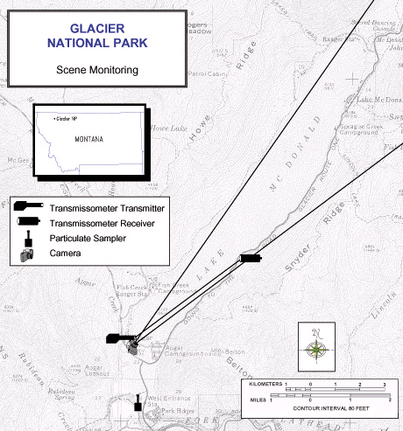

Map 5. The Glacier NP IMPROVE site, which is on Lake McDonald near Park Headquarters, started in 1988. This site monitors air quality characteristic of the northern GBW and in influenced by emission sources in the Flathead valley. The photo below is from the IMPROVE camera at Lake McDonald.

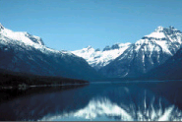

Photo 5. View from visibility camera in Glacier NP along Lake McDonald. An IMPROVE web camera in operational at the site and near real time photos can be viewed at <http://www.nps.gov/archive/glac/webcams/mcdcam.htm>

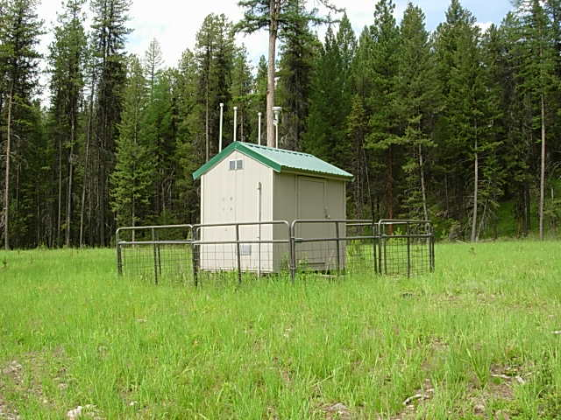

Photo 6. Monture Guard Station IMPROVE site, Lolo National Forest. This site is slightly influenced by emission sources in the Bitterroot valley, particularly Missoula. This site houses 4 modules which pump air in 2@24 hour periods. Filters are changed each Tuesday then sampled for a wide variety of chemical air quality constituents. A visibility camera associated with the site is located at Ovando.

Trend data is available at <http://vista.cira.colostate.edu/dev/web/AnnualSummaryDev/trends.aspx> which shows visibility trends since the stations were installed. The graphs below show trends in light extinction and deciviews which are indices of visibility. Air quality State Implementation Plan (SIP) for particulates is promulgated through the Montana Clean Air Act and implementing regulations. The deciview unit is a haze indexwhich is ameasure of visibility derived from calculated light extinction measurements so that uniform changes in the haze index correspond to uniform incremental changes in visual perception across the entire range of conditions from pristine to highly impaired. The haze index [in units of deciviews (dv)] is calculated directly from the total light extinction [bext expressed in inverse megameters (Mm-1)] as follows: HI = 10 in (bext/10). The trends for the Glacier NP IMPROVE site show generally stable to improving visibility trends through the period of record for both the 20% best and 20% worst days (see Graph 1). The worst visibility (highest light extinction and deciviews) occurred in 2000 and 2003 which were robust wildfire years in Glacier NP with extensive wildfire smoke impacts in the GBW.

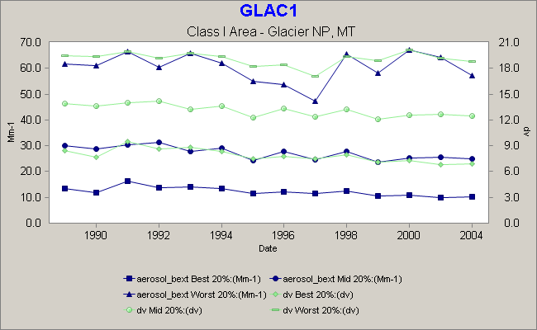

Graph 1. Glacier NP visibility data for 20% best and 20% worst days

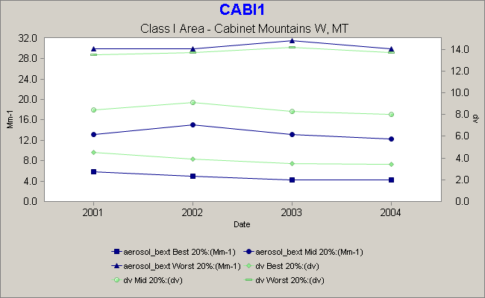

Graph 2. Cabinet Mountains visibility data for 20% best and 20% worst days

Both the Cabinet Mountains IMPROVE sites above (Graph 2) and the Monture IMPROVE site below (Graph 3), which were both established in 2000, had similar trends of generally improving visibility during the period of record. Both sites had the 20% worst visibility (light extinction and deciviews) during the robust wildfire year of 2003.

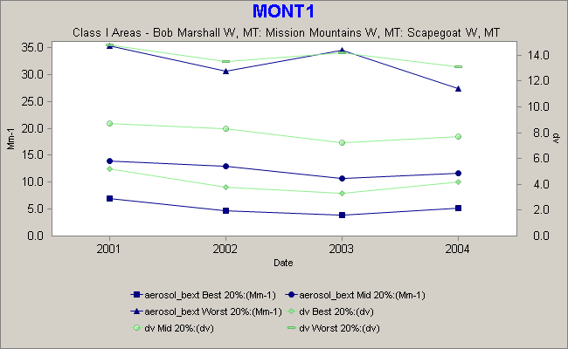

Graph 3. Monture site visibility data for 20% best and 20% worst days

The IMPROVE data was also converted for SVR (standard visual range in kilometers) and deciviews which shows the inverse correlation between SVR and deciviews. For the Glacier NP, Cabinet Mountains, and Monture sites visibility is closely coorelated to wildfire activity.

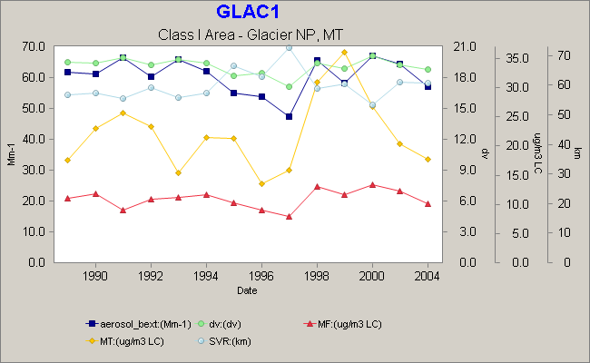

Graph 4. Particle, light extinction, and visibility trends for the Glacier NP IMPROVE site.

For the GLAC1, CABI1, and MONT1 sites the mass IMPROVE data demonstrates the correlation between particulates and light extinction (aerosol bext) and visibility (dv and SVR). The MF is fine mass (PM2.5 or particles < 2.5 um diameter). See Graphs 4, 5, and 6.

MT is total mass (PM10 or particles < 10 um diameter). MT – MF = CM or coarse mass which is a component of aerosol reconstructed extinction. The recorded MT was highest at Glacier in 2000 which was a robust wildfire year. The Glacier NP Headquarters was evacuated and visibility monitoring equipment was temporary shut down from the 71,000acre, Moose Fire (2001) and 52,874 acre Roberts Fire (2003).

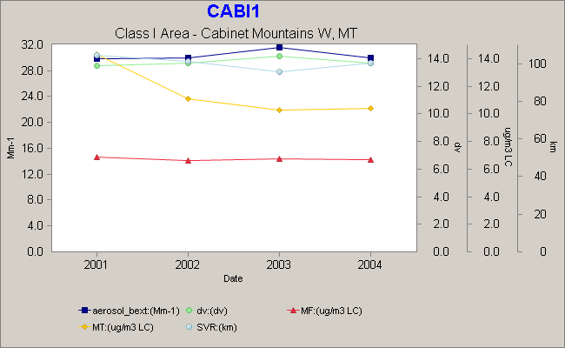

Graph 5. Particle, light extinction, and visibility trends for the Cabinet Mountains IMPROVE site.

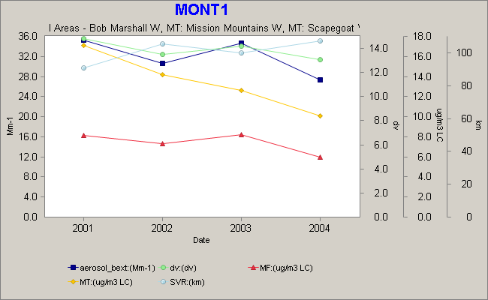

Graph 6. Particle, light extinction, and visibility trends for the Monture IMPROVE site.

The MONT1 and GLAC1 IMPROVE sites are proximate to the GBW with only very minor emission sources between these sites and the wilderness areas. The IMPROVE sites are therefore reasonable approximations of visibility conditions in the GBW.

Snow Chemistry

The United States Geological Survey (USGS) Water Resource Division in Colorado, in cooperation with the USFS, NPS, and multiple other agencies and interest groups has been monitoring 52 seasonal (late winter), depth integrated, bulk snowpack sites along the Continental Divide from New Mexico through Montana since 1993, (Ingersoll et. al., 2002a), See map 5 <http://pubs.usgs.gov/of/2001/ofr01-466/> . One of these sites, Noisy Basin, at T.28N, R.19W, SE1/4, section 25, is on the western edge of the Jewell Basin Hiking Area and 12 miles west of the GBW. Other sites include Apgar Mountain in Glacier NP about 5 miles NW of the GBW and at Big Mountain Ski Area about 19 miles west of the GBW. Bulk late winter snowpack samples provide a very useful diagnosis of chemical deposition (H+, Ca2+, Mg2+, Na+, K+, HN4+, SO4+, NO3-, and Cl-) from all transport sources (short and long range) through the late fall and winter period. The samples are collected in a depth integrated fashion prior to spring snowmelt rinsing of the snowpack which quickly flushes the soluble chemical constituents from the snowpacks (Ingersoll et. al., (2001, 2002, 2003, 2004, and 2005). The snowpack monitoring has documented generally decreasing levels of snowpack contaminants from south (New Mexico and Colorado) north through Montana. The Noisy Basin Mountain site has generally low (dilute) amounts of contaminants.

A map of snow survey locations and Region 1 Wilderness Areas within Montana and Idaho

Map 5. Snow Survey locations in USFS Region 1.

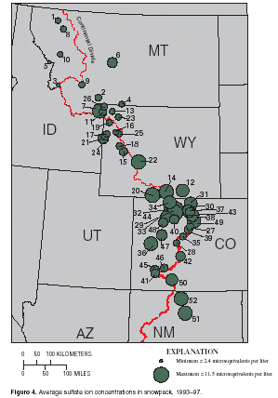

Map 6. Snowpack average sulfate ion concentration, 1993-1997

Sulfate ion concentration in USGS snow survey network, average values 1993-1997 from Ingersoll et.al. 2002. <http://pubs.usgs.gov/of/2001/ofr01-466/pdf/ofr01-466.pdf> The diameter of circle is representative of average sulfate concentration. Noisy Basin #8, Big Mountain #1, Snow Bowl #10, and all of the western Montana sites had low levels of sulfate relative to sites in Wyoming, Colorado, and New Mexico which are closer to industrial facilities (see Map 6). Subsequent snow chemistry monitoring has shown a slight decline in snow sulfate concentrations in Montana particularly site #6, Kings Hill (Lewis and Clark NF) which is downwind of the East Helena ASARCO smelter which was the largest source of SO2 emissions in Montana. The smelter shut down in 2001 with a corresponding reduction of Kings Hill snow sample sulfur concentrations.

National Atmospheric Deposition Program (NADP) Sites

A map of NADP site locations and Region 1 Wilderness Areas within Montana and Idaho

Map 7 - NADP sites in USFS Region 1.

The GBW is triangulated by 4 NADP (National Atmospheric Deposition Program) sites in Western Montana and Northern Idaho including the MT05 site at Glacier National Park (operated by the NPS), MT07 site at Clancy Montana (operated by the USGS), the Lost Trail Pass MT97 site (operated by the Bitterroot NF) and the Priest River Experimental Forest (operated by USFS Research). See Map 7. The NADP Program was initiated in 1978 to monitor geographical and temporal trends in the chemical composition of rain and snow (wet deposition) with the primary purpose of acid rain benchmark monitoring. The program was prompted by scientific evidence and public concern in the 1970’s that acid rain could be damaging aquatic ecosystems throughout the United States. The program grew steadily though the early 1980’s and has stabilized at about 200 sites. The NADP network is used by a wide variety of government administrators and university scientists in monitoring the amounts of atmospheric deposition and effects on agriculture, forests, rangelands, freshwater streams, lakes, and cultural resources. Atmospheric deposition is commonly referred as “acid rain” but can occur as acid snow, fog, or dry deposition. The NADP data from all sites is readily retrievable at the NADP web site at <http://nadp.sws.uiuc.edu>. The Glacier NP NADP site (MT05) is co-located with the IMPROVE site and was established on 6/3/1980 (see Photo 7).

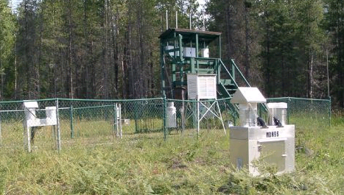

Photo 7. Glacier National Park (MT05) NADP site. The green tower in the background hosts the GNP IMPROVE site (GLAC1).

The Glacier NP (MT95 site) is the closest and most closely related site to the GBW. All NADP sites require access to the site each Tuesday, yearlong. Sample buckets are changed then shipped to the Central Analytical Lab in Illinois for a wide varied of chemical constituent analysis.

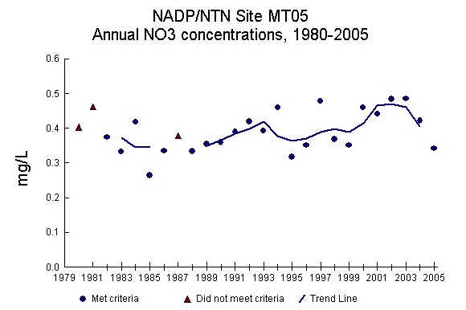

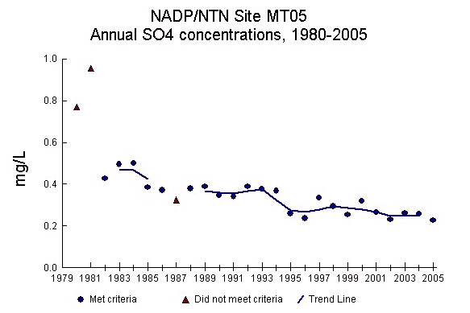

Graph 7. Nitrate and sulfate concentrations at Glacier NP.

An important parameter in trend analysis and acid deposition ecological significance is total wet deposition of sulfate and nitrate in kilograms/hectare (kg/ha). A major variable in total wet deposition is precipitation so that wet deposition is greater in high precipitation years. Annual NO3 and SO4 average concentration per year is shown in graph 7 for the Glacier NP NADP site MT05. Wet deposition is a function of total precipitation times concentration and is highly influenced by wet and drought years. In general, sulfate deposition slightly decreased through the period of record from 1980 through 2005. Annual nitrate deposition had a slight increase from 1980 through 2005. The increase in nitrate deposition at MT95 is consistent with overall trends for mobile source (vehicle) emissions in the Western US, which are increasing NOx emissions (Lynch, 1996, Peterson and Sullivan, 1998). In general NOx emissions are increasing in the Western US due to mobile sources (mainly vehicles) as the population grows as well as increasing small industrial facilities. The slight decrease in overall sulfate deposition is consistent with overall Western US trends as industrial SO2 sources have decreased. Many of the historic largest Western US SO2 sources have shut down or are improving air pollution control technology.

Lichens

Lichens can be useful biologic indicators of air quality since many lichen species are very sensitive to air pollutants and accumulate air contaminants in lichen thallus tissue.

Dr. Larry St. Clair, BYU, has been collecting lichen samples in USFS Class 1 areas since 1992 including samples in the Anaconda-Pitler, Selway Bitterroot, Cabinet Mountains, and Bob Marshall Wilderness (St. Clair, 2005). See map 8. Several sites on the periphery of the Bob Marshall Wilderness, including 3 near the Great Bear Wilderness, were sampled in 2002 and 2003 for lichen amounts, lichen species and community composition, and elemental analysis of the lichen thallus tissue. For the Bob Marshall Wilderness sites St. Clair found (2005) 54 general and 139 species. St. Clair concluded that the abundance of sensitive lichen indicator species and the high diversity of lichen species and well as substrate and growth form distribution patterns documents that the lichen flora in the Bob Marshall Wilderness is healthy and relatively un-impacted by air pollution. Lichens will continue to be assessed on approximately a 7 year interval with the next sampling in 2009-2010.

A map of lichen monitoring site locations and Region 1 Wilderness Areas within Montana and Idaho

Map 8. Lichens monitoring sites in USFS Region 1.

**Reference Lichen sites collected in or near the Bob Marshall Wilderness Complex:**

**Site No. 37:** 18 July 2002 (new collection site). Montana, Missoula County, along **Holland Falls Trail** (U.S. Forest Service Trail No. 416), near boundary of Bob Marshall Wilderness Area

**Site No. 38:** 18 July 2002 (new collection site). Montana, Powell County, vicinity of **Pyramid Pass Trailhead**, near boundary of Bob Marshall Wilderness Area;

**Site No. 39:** 19 July 2002 (new collection site). Montana, Powell County, vicinity of **Lodgepole Creek Trailhead**, near boundary of Bob Marshall Wilderness Area;

**Site No. 40:** 7 July 2003 (new collection site). Montana, Missoula County, Flathead National Forest, vicinity of **Smith Creek Trailhead** (U.S. Forest Service Trail No. 29), near boundary of Bob Marshall Wilderness Area;

**Site No. 41:** 7 July 2003 (new collection site). Montana, Lake County, Flathead National Forest, along U.S. Forest Service Road No. 10502, vicinity of intersection with No Name Creek, near boundary of Bob Marshall Wilderness Area; GPS reading: 47º 46.570´ north latitude, 113º 41.766´ west longitude; elevation 4500 feet (1385 m). (Somewhere near **Inspiration Pass**)

**Site No. 42:** 8 July 2003 (new collection site). Montana, Flathead County, Flathead National Forest, vicinity of **Silvertip Trailhead** (U.S. Forest Service Trail No. 83), near boundary of Bob Marshall Wilderness Area;

**Site No. 43:** 8 July 2003 (new collection site). Montana, Flathead County, Flathead National Forest, vicinity of Meadow Creek Trailhead, near boundary of Bob Marshall Wilderness Area;

**Site No. 44:** 10 July 2003 (new collection site). Montana, Pondera County, Blackfeet Indian Reservation, along Eagle Creek, north of **Swift Reservoir**, near boundary of Bob Marshall Wilderness Area;

**Site No. 45:** 10 July 2003 (new collection site). Montana, Teton County, Lewis and Clark National Forest, vicinity of **West Fork of the Teton Campground**, near boundary of Bob Marshall Wilderness Area;

**Site No. 46:** 10 July 2003 (new collection site). Montana, Teton County, Lewis and Clark National Forest, vicinity of **South Fork Teton Trailhead**, near boundary of Bob Marshall Wilderness Area;

**Site No. 47:** 11 July 2003 (new collection site). Montana, Teton County, Lewis and Clark National Forest, vicinity of **Mortimer Gulch Trailhead**, near boundary of Bob Marshall Wilderness Area;

**Site No. 48:** 11 July 2003 (new collection site). Montana, Lewis and Clark County, Lewis and Clark National Forest, vicinity of **South Fork Sun River Trailhead** (along U.S. Forest Service Trail No. 202), near boundary of Bob Marshall Wilderness Area;

The above sites are detailed in “Lichen Monitoring for Anaconda-Pintler, Cabinet Mountains, Selway Bitterroot, Gates of the Mountains, and Bob Marshall Wilderness Areas   4/2005”, also available at USFS Region One Air Quality website: <http://www.fs.fed.us/r1/gallatin/resources/air/reports/index.shtml>

5) Wilderness Air Quality Values

**Great Bear Wilderness**

Visibility/Scenery

Visibility and scenery is the key WAQV for the Great Bear Wilderness. Scenic vistas are the key sensitve receptors for the GBW and visibility is the key indicator. The GBW borders the Bob Marshall Wilderness and along with the Scapegoat Wilderness collectively form the Bob Marshall Wilderness complex which over 1.5 million acres (6,070 km²) of wild landscapes. Glacier National Park is separated from the Great Bear Wilderness by US Highway 2 and the Middle Fork of the Flathead River.

The GBW is located west of the Continental Divide which forms part of the eastern boundary. Great Northern Mountain (8,705 ft/2,653 m) is the highest peak in the wilderness which is dominated by dozens of other mountains, all part of the Rocky Mountain Front a huge overthrust fault that spans for 400 miles (643 km) through Montana and Canada. The GBW includes part of the headwaters of the Wild and Scenic designated Middle Fork of the Flathead River, which flows for 35 miles through the wilderness. Scenic vistas from high peaks, meadows, rivers, and key vantage points along the trail system are the major WAQV (Wilderness Air Quality Value) in the Great Bear Wilderness.

The 85 lakes in the GBW are also an important WAQV but have considerable alkalinity buffering due to the calcium carbonate dominated parent material so are not sensitive to existing or anticipated acid deposition levels in the area.

6) Monitoring Plan

This plan is designed to specify appropriate monitoring to protect the Class 2 WAQVs in the Great Bear Wilderness and to meet the Wilderness Stewardship Challenge to achieve the objectives of the Air Element #3 http://www.wilderness.net/index.cfm?fuse=toolboxes&sec=air

The Wilderness Stewardship Challenge steps include selecting air quality values with an interdisciplinary team, rank air quality values, select receptors, and identify indicators to measure at the sensitive receptors. For the Great Bear Wilderness, the process included a review of existing air quality information in and adjacent to the GBW with a determination that existing monitoring in the IMPROVE, NADP, USGS snow chemistry, and USFS lichen monitoring networks is sufficient to characterize and monitor GBW air quality for the key sensitive receptor (scenic vistas) and sensitive indicator (visibility). This GBW monitoring plan proposes not to do additional NADP, visibility, particulate monitoring at this time since these air quality parameters are being adequately monitored in existing networks. In the future an additional IMPROVE or NADP site could be added to augment the downwind information from the robust population growth in the Flathead valley. Air quality monitoring in the Great Bear Wilderness will continue to be done with the existing IMPROVE, NADP, USGS snow chemistry, and USFS lichen monitoring networks and tracked and tabulated by USFS R1 Air Resource Management staff. At the conclusion of the R1 Class 2 AQRV plan preparation, in 2008, the R1 AQ Program is planning to update the 7 Class 1 Wilderness AQRV plans summarize in a consolidated R1 Wilderness air quality assessment and monitoring plan. This GBW WAQV plan will need to be re-evaluated within a 5-10 year interval to insure monitoring sufficiency, particularly if the upper Flathead valley population continues to grow. Specific monitoring near the GBW includes:

**Lakes:** Although lakes in the GBW are an important resource, lake chemistry is not an effective indicator of air pollution levels in the GBW since visibility would be severely degraded before lake acidification becomes a problem.

**Visibility:** Visibility in the GBW is being reasonably monitored by the “umbrella” of the IMPROVE visibility monitoring sites at the Glacier National Park IMPROVE site (GLAC1) on Lake McDonald 4 miles from the NW border of the GBW, Cabinet Mountains (CABI1) IMPROVE site 93 miles west of the GBW, and the Monture Guard Station IMPROVE site (MONT1) 60 miles to the south. Visibility at these 3 IMPROVE sites has documented good visibility with periodic reduction during periods of active wildfire, particularly in 2003. No large upwind industrial sources of air pollution affect these sites although the Glacier NP site has some influence by emission sources in the upper Flathead Valley. No additional visibility monitoring stations are recommended or planned for the GBW.

**Snow Chemistry**

Snow chemistry will continue to be cooperatively monitored in late February and early March by the USGS Water Resource Division in Colorado. The 3 sites include Noisy Basin on the western edge of the Jewell Basin Hiking Area and 12 miles west of the GBW, and Apgar Mountain in Glacier NP about 5 miles NW of the GBW, and at Big Mountain Ski Area about 19 miles west of the GBW. These 3 sites will continue to be cooperatively operated with USGS, Flathead NF, and NPS staff with financial support from the USFS R1 Air Quality Program budget and the NPS. Chemical analysis (H+, Ca2+, Mg2+, Na+, K+, HN4+, SO4+, NO3-, and Cl-) is analyzed in the USGS laboratory in Denver, Colorado with data analysis and reporting completed by USGS Water Resource Division in Colorado. Snowpack chemistry data and reports are available at the USGS web site at <http://co.water.usgs.gov/Pubs/index.html#OFR>

References

Acheson, 1989. Bob Marshall Wilderness Air Quality Related Values Management Plan, Colorado State University Dept. of Earth Resources, Fort Collins, Colorado.

American Public Health Association (APHA). 1989. Standard Methods for the Examination of Water and Wastewater, 17th Ed. American Public Health Association, Washington, D.C

Elliott D.L., C.G. Holladay, W.R. Barchet, H.P. Foote, and W.F. Sandusky, 1986. Wind Energy Resource Atlas of the United States. US Department of Energy. p. 50. ersonal Communication, Montana Natural Heritage Program, 1990.

Ingersoll, G., Alisa Mast, David W. Clow, Leora Nanus, Donald H. Campbell, and Heather Handran 2001. Rocky Mountain Snowpack Chemistry at Selected Sites for 2001. , USGS Open-File Report 03-48, 11 p., 4 figs.

Ingersoll, G, John T. Turk, M. Alisa Mast, David W. Clow, Donald H. Campbell, *and* Zelda C. Bailey, 2002. Rocky Mountain Snowpack Chemistry Network: History, Methods, and the Importance of Monitoring Mountain Ecosystems, USGS Open-File Report 01–466, 14 p., 5 figs.

Ingersoll G., Alisa Mast, Leora Nanus, David J. Manthorne, David W. Clow, Heather M. Handran, Jesse A. Winterringer, and Donald H. Campbell 2004. Rocky Mountain Snowpack Chemistry at Selected Sites, 2002 . Open-File Report 2004-1027.

Ingersoll, G., M. Alisa Mast, Leora Nanus, David J. Manthorne, Heather H. Handran, Douglas M. Hulstrand, and Jesse Winterringer, 2005. Rocky Mountain Snowpack Chemistry at Selected Sites, 2003. **USGS Open-File Report 2005-1332**, 17 p., 6 figs.

Landers, D.H., J.M. Eilers, D.F. Braake, W.S. Overton, P.E. Kellar, M.E. Silverstein, R.D. Schonbroad, R.E. Crowe, R.A. Linthurst, J.M. Omernnik, S.A. Teague, and E.P. Miller, 1987, Characteristics of Lakes in the Western United States. Voll LL. Data Compendium for Selected Physical land Chemical Variables. EPA-600/13-054b, Washington D.C.

Lynch, J.A., J.W. Grimm, and V.C. Bowersox, 1996. Trends in Precipitation Chemistry in the United States: a National Perspective, 1980-1992. Atmos. Environ. 29:1231-1246.

NADP, 2007. National Atmospheric Deposition Program (NRSP-3)/National Trends Network, NADP Program Office, Illinois State Water Survey, 2204 Griffith Dr., Champaign, IL. <http://nadp.sws.uiuc.edu>

Peterson D.L. and T.A. Sullivan, 1998. Assessment of Air Quality and Air Pollutant Impacts in National Parks of the Rocky Mountains and Northern Great Plains. For the National Park Service – Air Resource Division. Environmental Chemistry, Inc., Corvallis, Or.

St. Clair L, S.B St. Clair, and B.D St. Clair, 2005. Re-inventory of the Lichen Bio-monitoring Program and Baseline for Selected Sites in the Anaconda-Pinter, Cabinet Mountains, and Selway Bitterroot Wilderness Areas, Montana and Idaho (Originally collected in July-August 1992, 1992, and 1994) and Establishment of Lichen Bio-monitoring Programs and Baselines in the Gates of the Mountains, Mission Mountains, and Bob Marshall Wilderness Areas, Montana. Brigham Young University, Provo, Utah.

Story, MT. 1991. Forest Service Region a Wilderness Lake Data Summary. Gallatin NF.

Story, MT, 1996. Air Quality Related Values Monitoring Plan for the Scapegoat Wilderness, Helena, Lewis and Clark, and Lolo National Forests. Bozeman, MT.

USFS, 1987. Bob Marshall, Great Bear, Scapegoat Wilderness. Recreation Management Direction. Flathead, Helena, Lewis & Clark, Lolo NF’s.

USFS, 2004, National 10-Year Wilderness Stewardship Challenge

USFS, 2004, National 10-Year Wilderness Stewardship Challenge, [Tools for Achieving the National 10YWSC](http://www.wilderness.net/index.cfm?fuse=toolboxes), Element 3 – Air Quality Monitoring. http://www.wilderness.net/index.cfm?fuse=NWPS&sec=manageFS