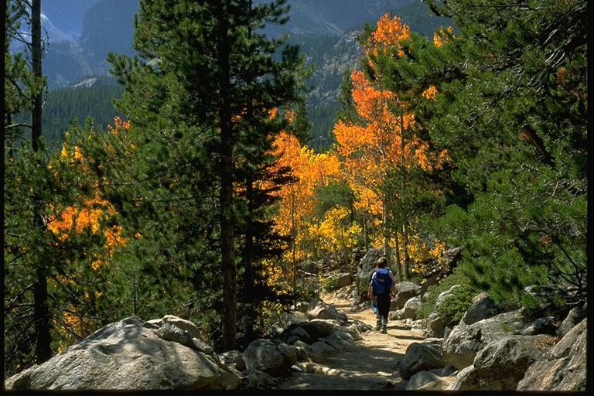
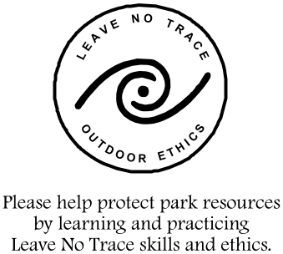

+

Rocky Mountain National Park
Goals of the Backcountry/Wilderness Management Plan

- Manage the backcountry/wilderness resource in accordance with the Wilderness Act,
the National Park Service Organic Act, Rocky Mountain National Park's enabling
legislation, and National Park Service policies.
- Protect and preserve natural and cultural resources and the integrity of the backcountry/wilderness character for present and future generations.
- Provide for the public's maximum freedom of use and enjoyment of the backcountry/
wilderness in a manner that will protect the quality of the backcountry/wilderness
natural and cultural resources.
- Provide for public understanding and support of backcountry/wilderness values.

National Park Service
Backcountry/Wilderness Management Plan
Rocky Mountain National Park
Estes Park, Colorado 80517

OFFICIAL BUSINESS
PENALTY FOR PRIVATE USE $300

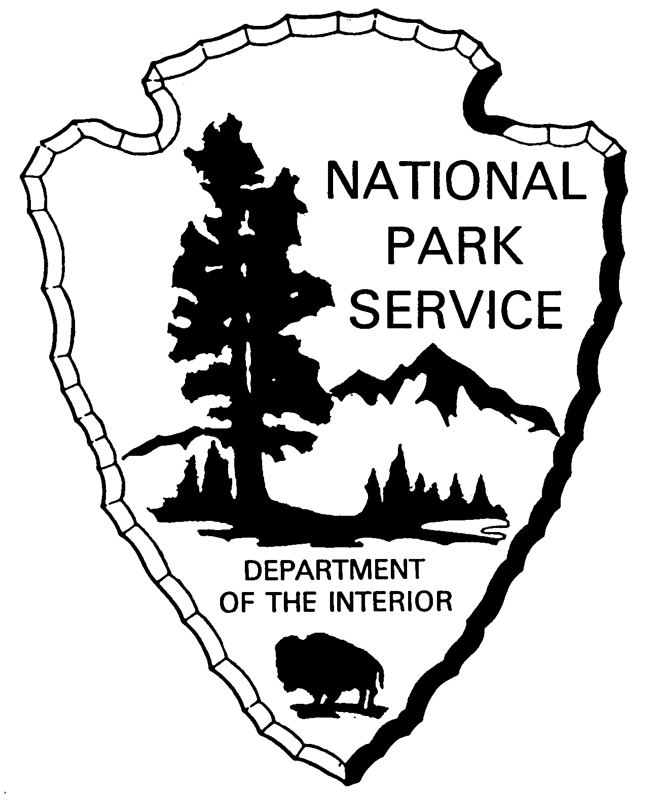

Rocky Mountain National Park
Backcountry/Wilderness
Management Plan
March 1998 An update of the planning process
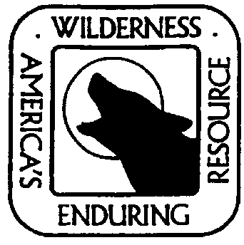

Superintendent's Message

We would like to take this opportunity to update you on the progress of the Backcountry/Wilderness Management Planning process. Through a series of workshops, a scoping brochure and web page, we collected your ideas about issues and concerns, which should be addressed in the plan. Our planning team used those comments to focus the scope of the plan and develop a draft outline.

Initial fieldwork was conducted last summer to determine the current condition of the backcountry/ wilderness resource. Similar work will continue this summer.

We thank you for your assistance so far and will be asking for additional input as we work our way through the planning process.

Sincerely,

A. Durand Jones
Significant Issues

There were 10 significant issues identified from internal and external comments. These issues will be addressed through a series of steps in the planning process: 1) developing desired conditions consisting of management class (MC) descriptions; 2) comparing desired conditions to existing conditions; 3) developing MC standards and guidelines that can be consistent or vary by MC depending on the issue; 4) identify alternative MC allocations and management actions for each alternative.

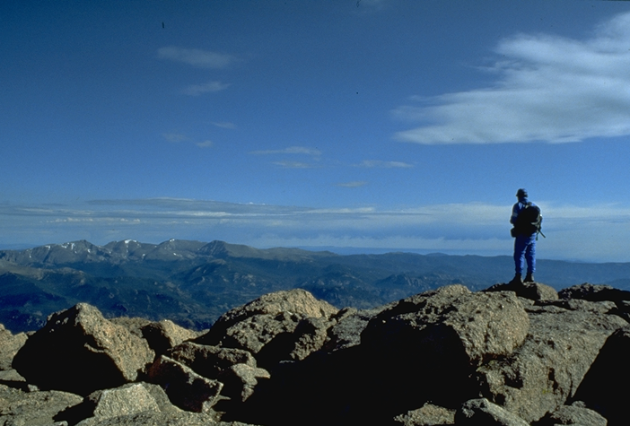

The following is a list of the 10 significant issues.

- Education
- Recreational use
- Trails and trailheads
- Overnight permit system
- Camp areas
- Appropriate facilities
- Administrative actions
- Research activities
- Resource impacts
- Social impacts

Other Issues

Some issues that were raised, such as wildland fire and commercial services, are discussed under separate management plans and will be linked to this plan for consistency.

Other issues, such as air and water quality, and fish and wildlife management, will be addressed in the plan by way of setting general guidance.

Summary

We value your ideas and need your continued support during this planning process.
As you visit or think about the park this summer, take note of anything you want to bring to our attention during future comment periods. We will continue to work with you to ensure the highest quality plan possible. That will lead to the best enjoyment and protection of Rocky's backcountry/wilderness resource.

Visit our planning web page at … http://www.nps.gov/planning/romowild

