**THE BIG PICTURE**

Desert Rehabilitation in wilderness is the result of a variety of techniques that together provide a foundation for the restoration of vehicular intrusions. However, the desert rehab described in this brochure is ultimately a waiting game since no live vegetation is planted. The following techniques are simply a method of site preparation in which windblown seeds are gathered and means of providing shade and collecting water is established. The true re-vegetation will not begin until it rains.

Pitting and vertical mulch is the only technique that can directly accelerate natural re-vegetation. Other techniques work in conjunction with pitting and vertical mulch to camouflage the site and help create a visual barrier. This may allow natural re-vegetation to occur by reducing the incidence of vehicular use.

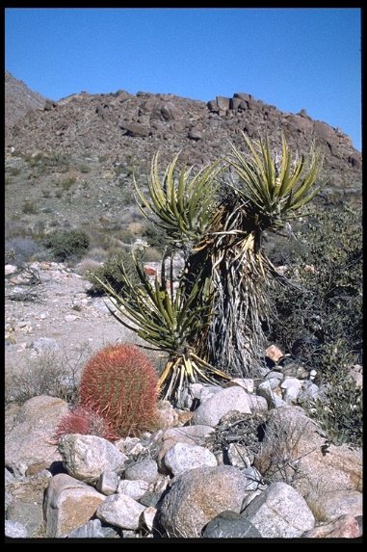

Martin Young and Andrea Demmon 8/5/03 draft

**Desert Rehabilitation Techniques**

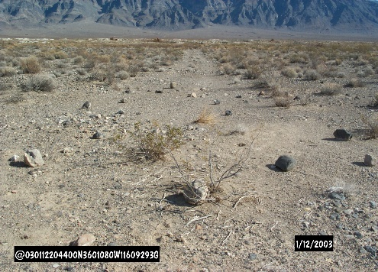

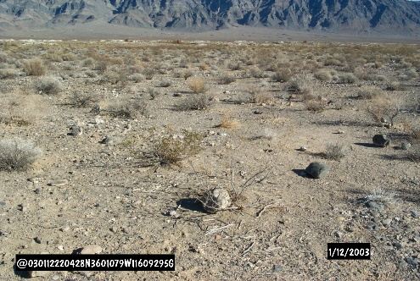

**Pitting & Vertical Mulch**

**Pitting** - shallow, 6 – 8” deep holes dug in disturbed areas

The pits need to have shallow sides (resembling a satellite dish) so that a baby tortoise will not get stuck inside.

**Vertical Mulch** – dead vegetation placed in or on the ground to act as a natural barrier for seed collection and provide shade for pits

Vertical Mulch may range from small shrubs to entire ocotillo or Joshua trees.

Pitting and Vertical Mulch are the keys to desert restoration. In combination, the two techniques aid in breaking up soil that has become extremely compacted after years of vehicular use. A microclimate is formed in each pit as water and shade provide a milder environment for captured windblown seeds to germinate.

**Creating a Visual Barrier**

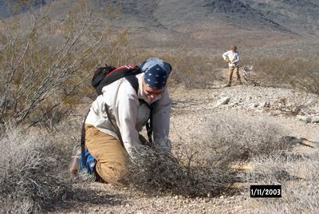

When attempting to camouflage an intrusion, it is important to break-up any linear features like lines of plants or berms. At the same time, the site needs to blend into its environment by matching the vegetation type and density, color, and texture of the surrounding desert.

**How to be a Master of Disguise:**

Use the techniques provided in this brochure to mimic the surrounding vegetation, color, and soil texture.

* **Vertical Mulch** – Use vegetation of the same type and color as those around the intrusion. Plant and scatter dead material in a ratio similar to the surroundings.
* **Rockwork** – Scatter rocks of the same size, color, and density as the surroundings. Extend natural lines of rocks that may cross sections of the intrusion.

To camouflage an intrusion, restoration work should disguise any visual indicators of the route for the entire line-of-sight, or for as far as the eye can see from any access points.

It is important to note that several factors can make disguising a route difficult. Remember that pitting and vertical mulch is the most important restoration technique and can be done in areas without attempting to camouflage the intrusion!

**Raking & Sweeping**

**Raking & Sweeping** – removal of tracks mostly in sandy wash areas

Raking and sweeping the desert helps to erase tracks quickly and efficiently.

Always use the rake with the teeth pointed up, away from the ground so rather then digging you are only dragging sand and soil.

It is important to note that Raking and Sweeping in certain areas can cause more damage than good.

The shifting of the loose dirt may help to erase tracks but could also possibly make the tracks more obvious if it causes color changes in the soil. At times, these color changes can make the intrusion more conspicuous than the original tracks.

If this technique is chosen as a tool for rehab, do a little, then step back and look to see what effects may be.

[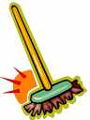](http://www.qksrv.net/click-1300521-10281960)



Clipart from Acclaim Art©