Fire Information
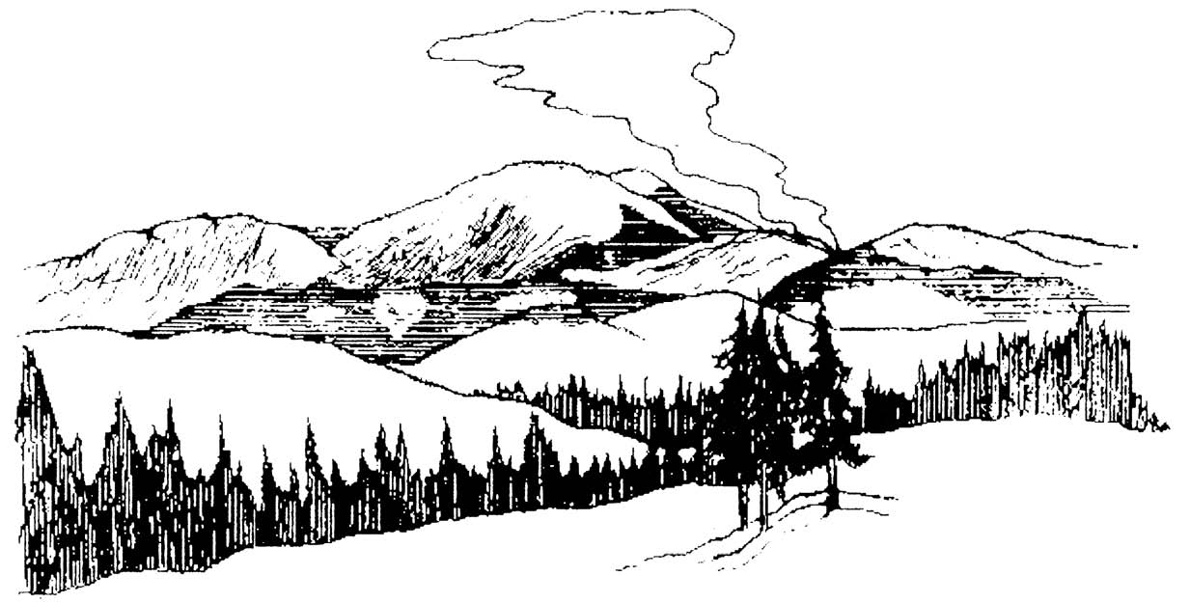
A wildland fire is burning in the _____________________ drainage. The fire was detected on ___/___/___, and is being managed as part of the natural process that has shaped the environment you are enjoying today.
The fire started at N___ ___.___’ x W___ ___,___’
or
Township___N, Range___W, Section___,___1/4

The size of the fire on ___/___ was approximately _______ acres.

If your travel takes you near this or another wildland fire, be aware of these hazards:

- Rapidly spreading flames
- Thick smoke and limited visibility
- Falling snags
- Rolling logs and rocks

In recent burned areas, hazards persist including falling trees, rolling logs and rocks, and holes from burned out stumps.

Please consider these hazards when entering the area and make appropriate safety considerations, which may include changing your travel plans.

Have a safe trip!

For additional information contact:

