Trail Closed
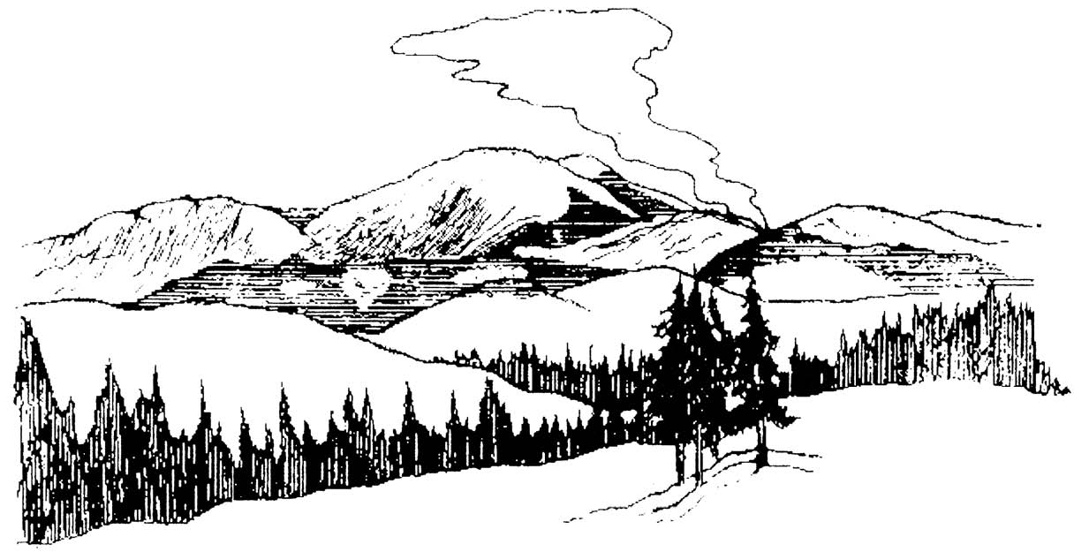
The trail behind this sign is closed for public safety.

A wildland fire is burning on or near this trail. Hazards include:

- Rapidly spreading flames
- Thick smoke and limited visibility
- Falling snags
- Rolling logs and rocks

This trail will be opened when conditions allow for safe passage.

In recent burned areas, hazards persist including falling trees, rolling logs and rocks, and holes from burned out stumps.

The following trails are closed by special order:___________________________________
___________________________________________________________________________________________________________________________________________________________________________________________________________________________

Potential alternative routes include:____________________________________________
___________________________________________________________________________________________________________________________________________________________________________________________________________________________

Have a safe trip!

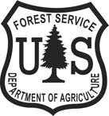
For additional information contact:

