Wilderness Visitors
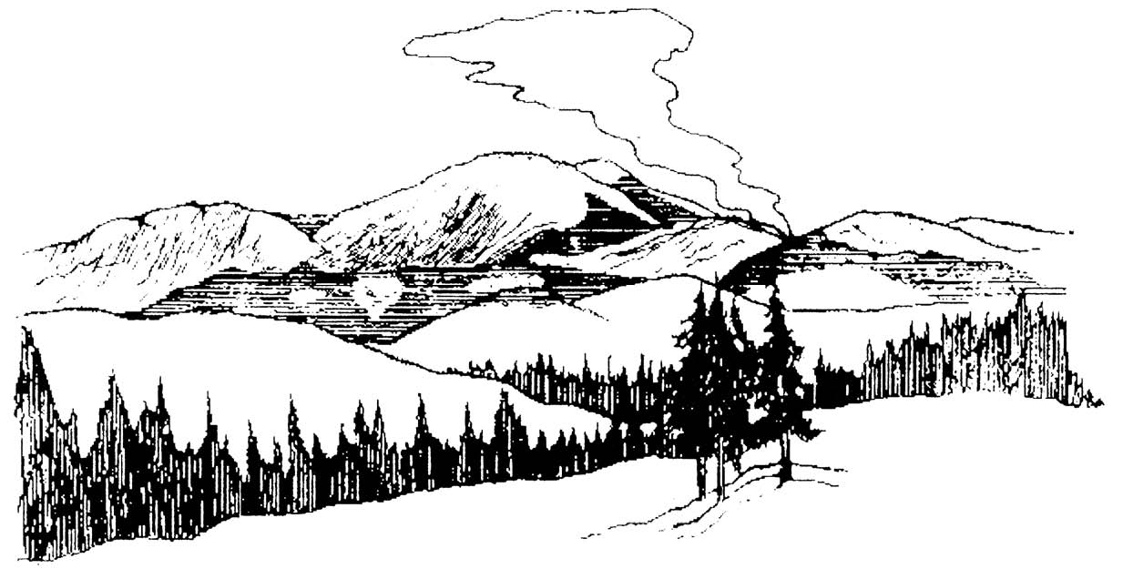

You are entering a wilderness area where wildland fires are burning as part of the natural process that has shaped the environment you are enjoying today.

If your travel takes you near this or another wildland fire, be aware of these hazards:

- Rapidly spreading flames
- Thick smoke and limited visibility
- Falling snags
- Rolling logs and rocks

In recent burned areas, hazards persist including falling trees, rolling logs and rocks, and holes from burned out stumps.

Please consider these hazards when entering the area and make appropriate safety considerations, which may include changing your travel plans.

Contact the local ranger district office for fire and trail closure information prior to departing on your trip. Be aware that conditions may change quickly. Additional fire information may be posted near ongoing fires.

Have a safe trip!

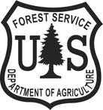
For additional information contact:

