

GLACIER RANGER DISTRICT

# USDA Forest Service, Chugach National Forest

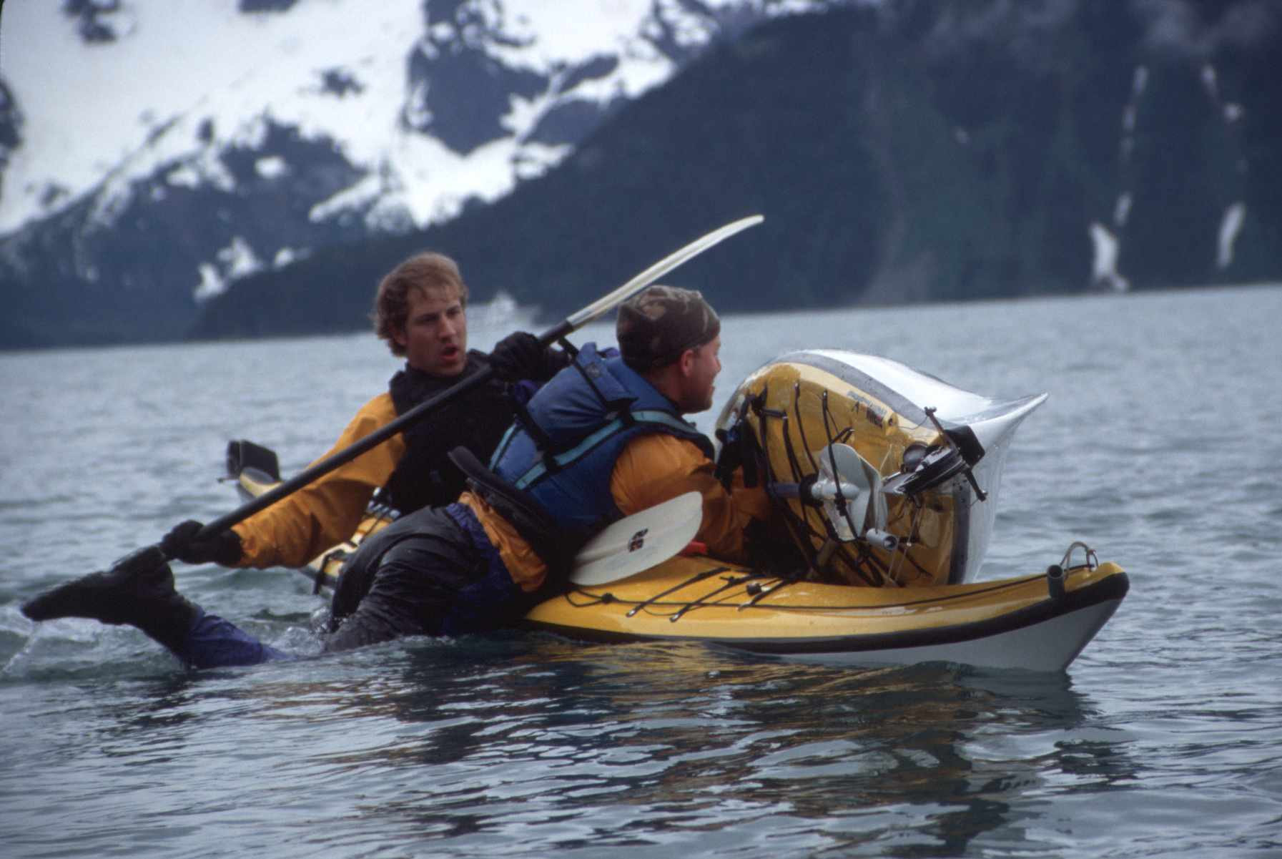

## Sea Kayak Operator Task Book

Task Book Assigned To:

Duty Station:

Task Book Initiated by:

Date Initiated:

**Purpose and Need**

The purpose of this task book is to lead employees through the Chugach National Forest sea kayak Operation training program. The program identifies and develops the skills needed to operate a sea kayak safely in the performance of your job. It also references manuals and literature that must be reviewed prior to certification. Last, the task book serves as a check list. It will validate your knowledge and skills as they pertain to safe sea kayak operation.

**Certification Process**

The process for sea kayak operation at this unit involves:

* Task book initiation from an instructor or supervisor.
* Completion of all tasks listed in task book.
* Recommendation by the designated specialized license examiner
* Certification will be authorized by a District Ranger or Forest Fleet Manager.

**Task Book Initiation**

The task book has been initiated based on completion of:

* Review and signing the sea kayaking Job Hazard Analysis

Date and Signature ______________

* Review of sections 15.16- paddle craft in the Health and Safety Code Handbook

Date and Signature ______________

**Responsibilities**

The **Trainee** is expected to have demonstrated proficiency for a task prior to requesting signoff by a trainer. It is the trainee’s responsibility to acquire these skill through reference materials, practice, and/or practical experience.

The **Trainer** will instruct the trainee in the skills needed. Once the skills have been completed or observed the trainer will initial and date those tasks. Upon task book completion, the trainer may recommend certification by the District Ranger or Forest Fleet Manager.

**Verification / Certification of Completed Task Book For Sea Kayak Operation**

**Final Evaluator’s Verification**

I verify that _________________________________has successfully completed this task book and has shown proficiency in all skills needed to operate a sea kayak safely and effectively at the level.

________________________________________________________________________

Final Evaluator’s Signature and Date

_______________________________________________________________________

Evaluator’s Printed Name, Title, Duty Station, and Phone Number

**Agency Certification**

I certify that ______________________________ has met all requirements needed to operate agency sea kayaks.

_____________________________________________________________________

Certifying Official’s Signature and Date

_____________________________________________________________________

Certifying Officer’s Name, Title, Duty Station, and Phone Number

**Certification Definitions and Required Elements**

**4a Kayak Operator (Kayak Supported Fieldwork)**

**Intent of certification:**

To allow use of kayaks in support of fieldwork. Allows for use of sea kayaks from USFS vessels, field camps or extended kayak supported trips. Operator need not be accompanied by a certified guide or certified Glacier District 4b operator.

The following *conditions* apply:

● Sea state will not exceed force 3 on the Beauford Scale for Kayakers.

The following *parameters* apply:

● Visibility will be such that land is always within view.

● Open water crossings of up to 2 miles permitted with a float plan in place, tailgate safety session completed and go-no-go decision made by all members of party.

● Kayaking will be generally near shore.

● May not assume responsibility or act in a guide capacity for other kayak operators.

● May not under any circumstances kayak in conditions exceeding 4a standards except while under the supervision of a 4b operator acting in guiding capacity or with a certified and approved sea kayaking guide.

● May operate within the safety parameters of a higher operator level.

For example: If a 4a operator is kayaking with a 4b operator, 4b safety parameters may be in place during the work period.

**Required elements from task book:**

1-9 all, 11abc, 12abc, 13, 14, 16a, 18ab, 19abd, 20-25all

**Additional skills, experience or training:**

Basic first aid and current CPR

**4b Kayak Operator (Kayak Ranger Operations)**

**Intent of certification:**

To allow for use of kayaks in support of backcountry ranger fieldwork and to act in an internal guiding and training capacity for Chugach National Forest personnel in support of fieldwork.

The following *conditions* apply:

● Sea conditions generally will not exceed force 4.

The following *parameters* apply:

● Visibility will range from obscured to clear.

● Paddling in conditions above force 3 will require a go-no-go analysis and tailgate safety session. All crossings of over 2 miles will require a tailgate safety session.

Crossings of over 5 miles will require a float plan to be in place under any conditions. A float plan will also be required for any crossing where the far shore is not visible due to weather conditions or when weather is predicted to deteriorate significantly.

● Kayaking may occur away from shore (greater than one half mile) for extended periods of time if shore is in view. If shore is obscured by weather during the paddling period a float plan must be in place and a tailgate safety session and go-no-go analysis must occur.

● May assume responsibility and act in a guiding capacity for other USFS staff while using sea kayaks in support of fieldwork.

● May provide training to Chugach National Forest staff for sea kayak use

● May sign and approve task book elements

● May not sign for verification of completion of task book

**Required elements from task book:**

All elements of task book must be completed

**Additional skills, experience or training:**

First aid and CPR

Minimum of 2 extended length sea kayaking trips in temperate coastal waters that required planning, packing, camping and navigation (applicability will be determined by examiner).

|  |  |
| --- | --- |
| Basic Skills and Knowledge | **Evaluator:**  **Initial and Date upon**  **Completion of Task** |
| 1. Completion of a Sea Kayaking In Alaska Introduction  a. Cold water immersion  b. Weather, tides and glacial features  c. Marine mammals and other animal hazards |  |
| 2. Introduction to sea kayaks and related equipment  a. District kayaks, fiberglass, plastic and folding  b. Safety features  c. Care and maintenance  d. Specialized paddling gear (spray skirts, pogies, pumps, paddle float)  e. Paddles, proper stowage of spare paddle |  |
| 3. PFD Introduction  a. Features  b. Proper fitting |  |
| 4. Introduction to specialized clothing and layering  a. Layering, dry suits, paddle jackets, bibs, hats, gloves, footwear |  |
| 5. Introduction to communication equipment  a. Marine VHF’s  b. Satellite Phone  c. Bendix King Radios |  |
| 6. Communication Protocols  a. Filing float plans properly  b. Radio protocols, communication with staff, district and vessels  c. Emergency use and protocols  d. Check in policy  e. Opening float plan while in the field |  |
| 7. Introduction to navigation  a. Tide books, planning using tides, currents and use with charts  b. Nautical Chart use  c. GPS and compass navigation |  |
| 8. Marine Rescue Situations  a. Specialized signaling and tracking equipment (PLB, VHF, strobes, dye markers, signal mirrors, flares and smoke signals)  b. Procedures for use  c. Checking signal devices, demonstrate operation and maintenance  d. Survival strategies, loss of kayak or essential gear or with kayak |  |
| 9. Shore Rescue Situations  a. Survival equipment and use  b. Survival techniques and rescue procedures for shore based rescue |  |
| Kayaking Skills Proficiency | **Evaluator:**  **Initial and Date**  **Upon Completion of Task** |
| 11. Demonstrate ability to effectively propel and maneuver kayak  a. Forward stroke, back stroke, sweep stroke, turning, stopping  b. Lateral movements  c. Maneuvering close to other kayaks for rescue or aid  d. Paddle set up (feathered or un-feathered) |  |
| 12. Demonstrate landing and launching techniques  a. Launching from beach under light conditions  b. Launching from dock or boat  c. Launching from beach under moderate conditions  d. Launching from beach under surf conditions  e. “Seal Landings and Launchings” off of exposed rock or elevated uneven ground |  |
| 13. Demonstrate ability to perform wet exit while maintaining control of paddle and kayak |  |
| 14. Demonstrate ability to perform paddle float self rescue |  |
| 15. Demonstrate ability to perform clearing flooded kayak rescues assisted and unassisted |  |
| 16. Demonstrate ability to rescue capsize victim  a. T-rescue  b. Double kayak rescue  c. Sling rescue for injured, incapacitated or overweight paddlers  d. Capsized entrapment techniques “hand of god” rescue  e. Flooded kayak rescue technique “the curl”  f. Sling rescue for overweight or injured paddler  g. Swimmer rescues |  |
| 17. Demonstrate use of towing systems  a. Towing kayak  b. Towing swimmer |  |
| 18. Demonstrate ability to perform support strokes  a. Low brace  b. High brace  c. Lateral movement strokes |  |

|  |  |
| --- | --- |
| **Additional Skills** | **Evaluator:**  **Initial and Date upon**  **Completion of task** |
| 19. Demonstrate Go-No-Go decision making process  a. Wind, waves, sea state, travel route and risk assessment  b. Weather assessment, possibility for change  c. Travel strategies for rough water paddling  d. Understanding of Beauford Scale for Kayaking |  |
| 20. Demonstrate open water crossing procedures  a. Conditions evaluation, Go-No-Go process  b. Preparation of kayaks, gear and emergency equipment  c. Crossing strategy, emergency procedures  d. Opening crossing float plan and protocols |  |
| 21. Bear mace storage and use during patrols |  |
| 22. Firearm transport and carry protocols for patrols |  |
| 23. Effective packing and unpacking of gear |  |
| 24. Preparation of kayak for days travel  a. Deck layout, emergency equipment placement  b. Food and water access  c. Navigation equipment, charts, GPS, compass  d. Spare paddle stowage |  |
| 25. PFD preparation and maintenance  a. Essential equipment check, batteries, expiration dates, function tests |  |

**Beauford Scale for Kayakers (Derived from Kayaking and Camping In Prince William Sound by Paul Twardock).**

|  |  |  |  |  |  |  |
| --- | --- | --- | --- | --- | --- | --- |
| **Force** | **Wind Speed** | **Wave Height off shore** | **Description of water** | **Signs on land** | **Category** | **Kayaker experience level** |
| 0 | 0-1 | 0 | Calm | No movement | Calm | Beginner |
| 1 | 1-3 | .25’ | Ripples, no crests | Smoke drifts | Light air | Beginner |
| 2 | 4-7 | 0-1’ | Small wavelets, no crests | Leaves rustle | Light breeze | Beginner |
| 3 | 8-12 | 1-2’ | Large wavelets, occasional white cap | Leaves in constant motion | Gentle breeze | Intermediate |
| 4 | 13-18 | 2-4’ | Small waves, regular white caps | Dust blowing, branches moving | Moderate breeze | Advanced |
| 5 | 19-24 | 4-8’ | Moderate waves, many whitecaps | Small trees sway | Fresh breeze | Very advanced |

Note: Scale goes to force 12 however kayaking is not allowed under any circumstances above force 5

**Definition of terms:**

*Conditions*: Describes the sea and wind state and should be referenced with the attached Beauford Scale for Kayaking.

*Safety Parameters*: Refers to the set of safety mitigating factors such as float plan requirements, distance from shore, qualification requirements of paddling partners and other specific safety requirements.